To Install Linux VM, Configure GCC, Setup Git Repository, Create Project Structure, Understand Shell Architecture.
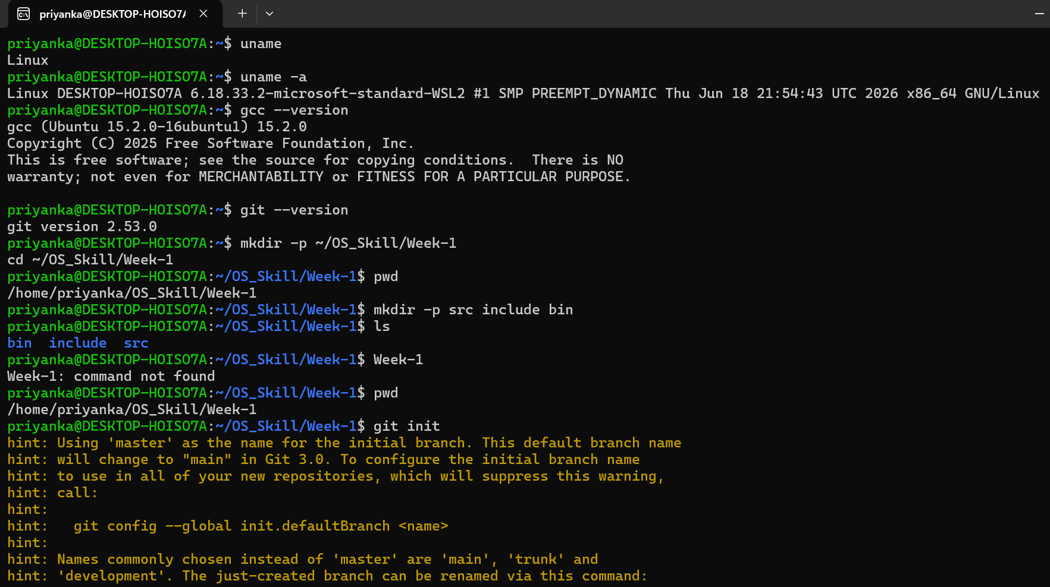

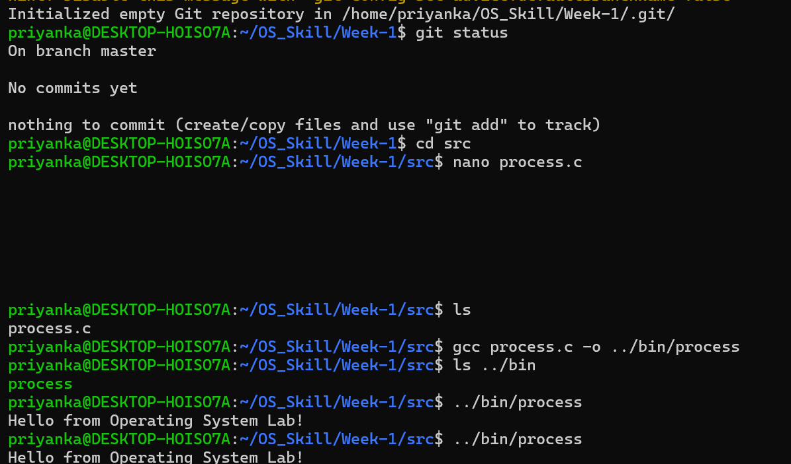

Code:

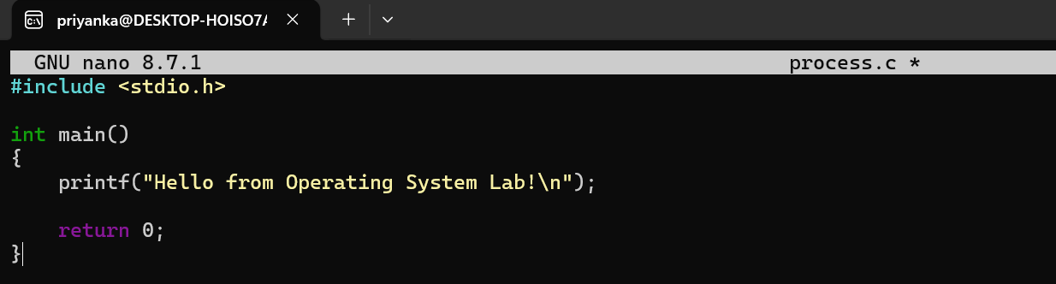
Build Initial Makefile
Code:
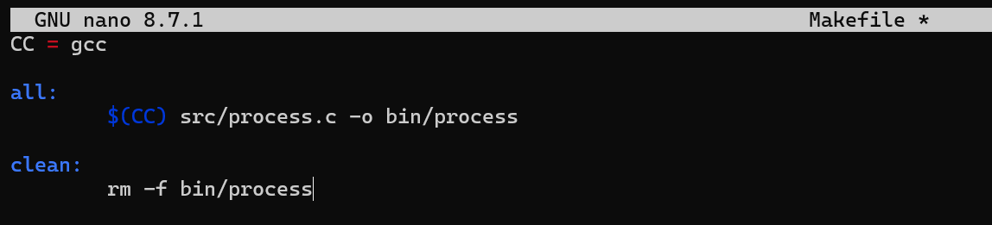
Output:
